

**Sharing Economy Platform**

**Technical Design Document**

|  |  |  |  |
| --- | --- | --- | --- |
|  | **Prepared By / Last Updated By** | **Reviewed By** | **Approved By** |
| **Name** | 1. Neha Sandeep Kharche  2. Kuruba Sai Meghana  3. Chinnahyata Sandeep |  |  |
| **Role** | Team members |  |  |
| **Signature** |  |  |  |
| **Date** |  |  |  |

**Table of Contents**

**1.0** **Introduction** **3**

**1.1** **Purpose of this document** **3**

**1.2** **Project overview** **3**

**2.0** **Solution Summary** **3**

**2.1** **Scope** **3**

**2.2** **Assumptions** **4**

**2.3** **Dependencies** **4**

**2.4** **Risks** **4**

**3.0** **Schematic Diagram** **5**

**4.0** **System Design** **6**

**4.1** **Proposed design** **6**

**4.2** **Component inventory** **6**

**5.0** **Database Design** **13**

**5.1** **Data Model** **13**

**5.2** **Tables Structure** **14**

**6.0** **Appendices** **15**

**6.1** **Glossary** **15**

**6.2** **Other** **15**

**7.0** **Terms & Conditions** **15**

**8.0** **Change Log** **15**

# 1.0 Introduction

## 1.1 Purpose of this document

The purpose of this High-Level Design (HLD) document is to add the necessary detail to the Sharing Economy Platform project description and document the technical design, component details and Database design. This will also capture the scope, assumptions, risk, dependencies of this project. This can be used as a reference manual to understand the interaction between modules at a high level.

## 1.2 Project overview

The central concept of the application is to allow the customer to shop virtually and buy products and book services of their desire. The application was designed into two modules. First is for the customer who wish to buy the products and book the services. Second is the vendor who maintains and updates the information about the products and services he is providing. Data entry into the application can be done through various screens designed for various levels of user.

# 

# 2.0 Solution Summary

## 2.1 Scope

The scope of this document is limited to addressing the use cases from a user, quality, and non-functional perspective. It presents the structure of the system by using mildly technical terms which should be understandable.

## 2.2 Assumptions

* Once the application is built on login registered users and vendors can be retrieved from the database.
* The User profile will be maintained by the User. The Vendor profile will be maintained by the Vendor.
* Any changes to the design mentioned in the BRD would be taken as a Change Request

## 2.3 Dependencies

* Availability of database design characteristics & access shall be defined.
* Resource availability throughout each of the sprint

## 2.4 Risks

If there is any failure in account creation process, the system should be able to handle such a financial risk.

# 3.0 Schematic Diagram

A schematic, or schematic diagram, is a representation of the elements of a [system](https://en.wikipedia.org/wiki/System) using abstract, graphic [symbols](https://en.wikipedia.org/wiki/Symbol) rather than realistic pictures. It gives an overview of overall system.

**SEP_Pic-11.0 Overview of Sharing Economy Platform**

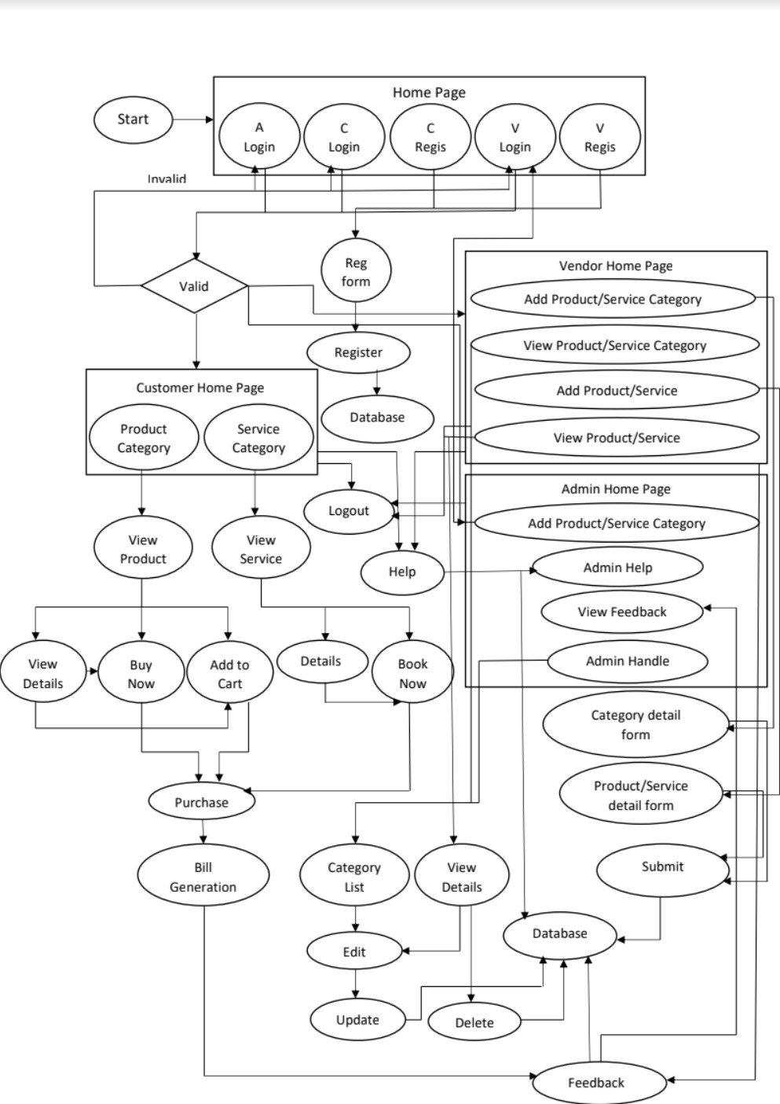

# 4.0 System Design

## 4.1 Proposed design

The proposed system design focuses on the detailed implementation of the feasible system. It consists of two phases namely Logical Design and Physical Design.

* During logical design phase the analyst describes inputs (sources),output s(destinations), databases (data sores) and procedures (data flows) all in a format that meets the user requirements. The analyst also specifies the needs of the user at a level that virtually determines the information flow in and out of the system and the data resources. Here the logical design is done through data flow diagrams and database design.
* The physical design is followed by coding. Physical design produces the working system by defining the design specifications, which specify exactly what the candidate system must do. The programmers write necessary programs that accept input from the user, perform necessary processing on accepted data and produce the required report on a hard copy or display it on the screen.

## 4.2 Component inventory

* **Role Selection** – User will enter into a web page and find three roles to select. Admin, Vendor and the other is Customer. Once the user selects Vendor or Customer role, the page will guide the user to any of the login pages and if the user has not yet registered, he can go with the option “click here to register” which will guide him to the respective registration page. If the user selects Admin role, it will redirect to login page.
* **Registration and Login** – will be used by the Vendor and Customer to register and login into the system and also to edit their respective registration details in the system. If Vendor and Customer forget the password so there is option for reset password.
* **Customer Home** – The Customer should be able to view the products/services available provided by the vendor. The customer also has to able to filter them by category. It should list the products based on the selected category.
* **Add to Cart** – The Customer can add the products to the cart and book the services provided by the vendor. And respective checkout process need to be done.
* **Feedback -** The Customer should be able to provide feedback for product/service.
* **Vendor Home –** The Vendor should be able to add the category for product and service.
* **Add product/service Category –** The vendor provide the different categories for product and service. They are able to view/update categories.
* **Add product/service Details** –The vendor has to give the details about the products or the services he is providing along with category. They are able to add/update/delete the product/service details.
* **Admin Home –** As an Admin, they view and provide resolution for the help request. As an Admin, they are also able to add product/service category.
* **Feedback –** User should be able to write review**.**
* **Help** – As a user, I should able to get a help.

**HOME PAGE**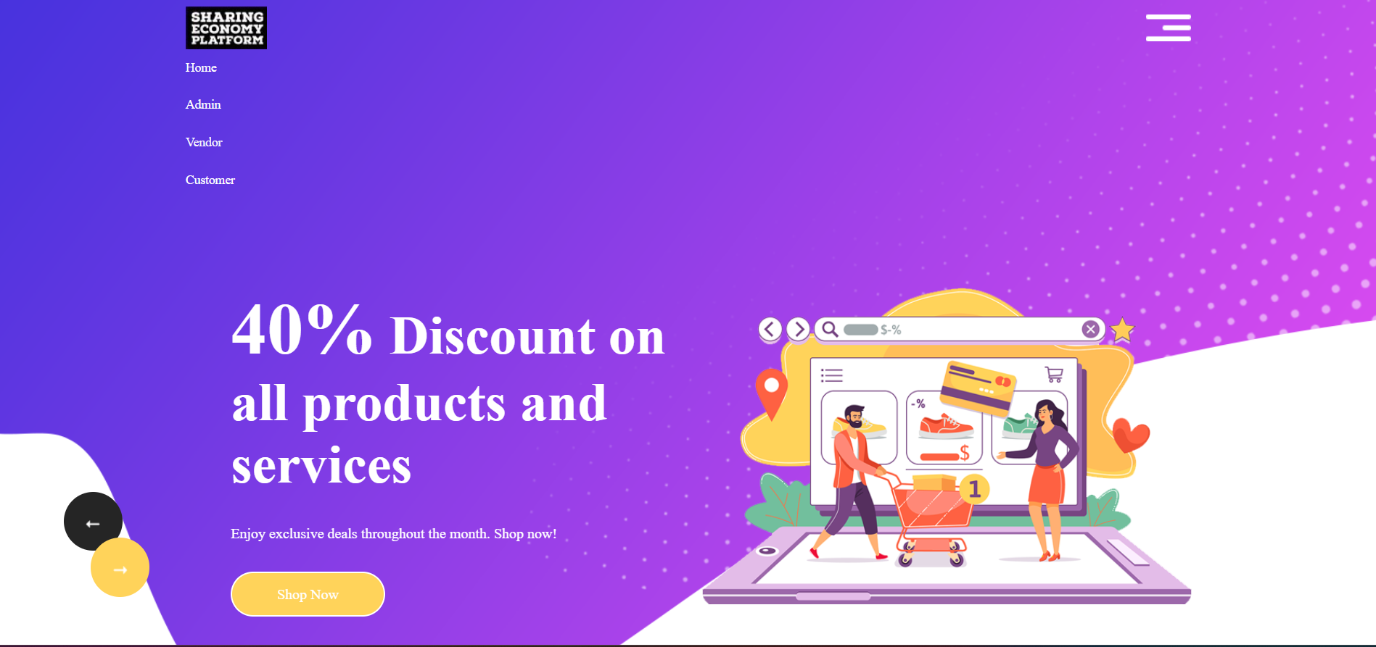

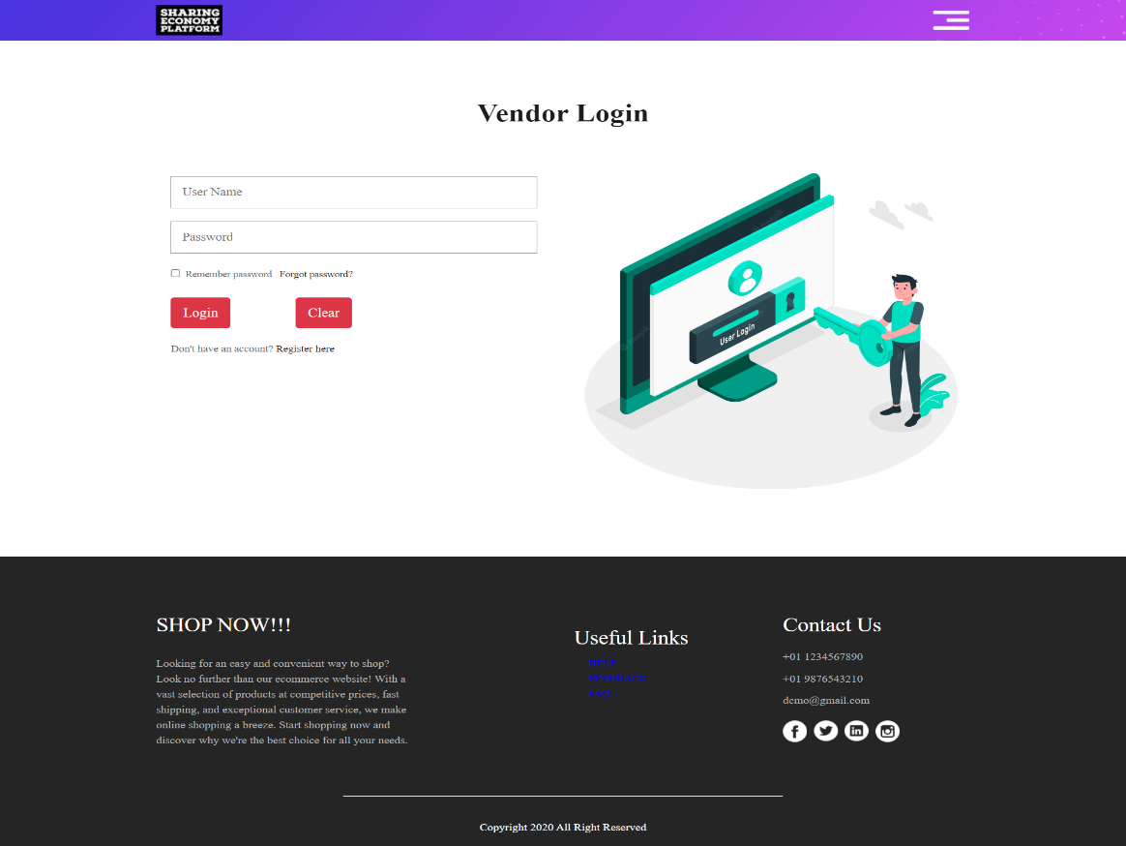**VENDOR LOGIN**

**VENDOR HOME**

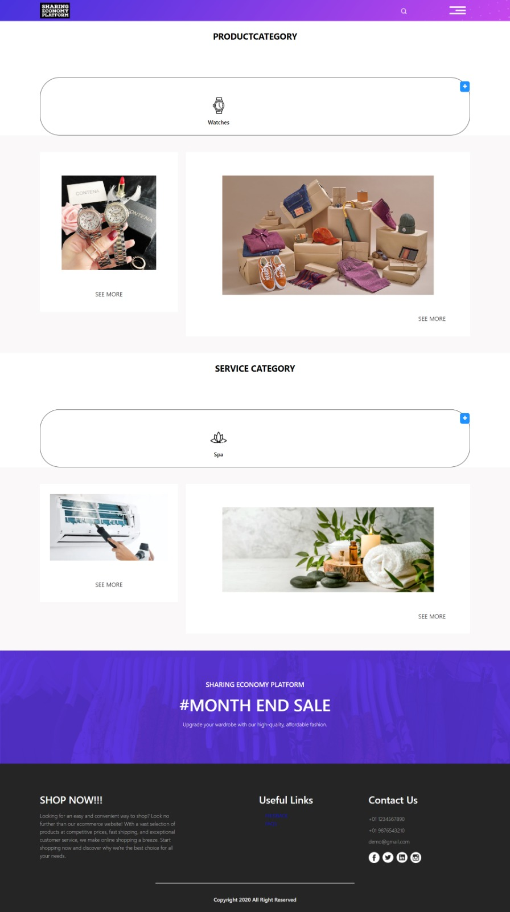

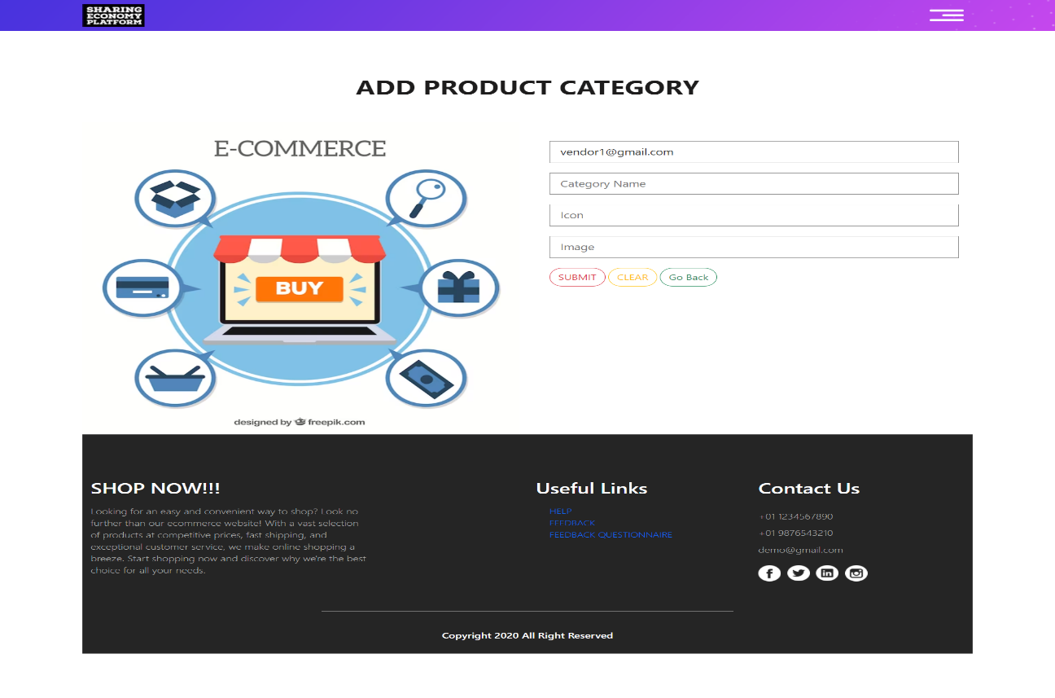**ADD PRODUCT CATEGORY**

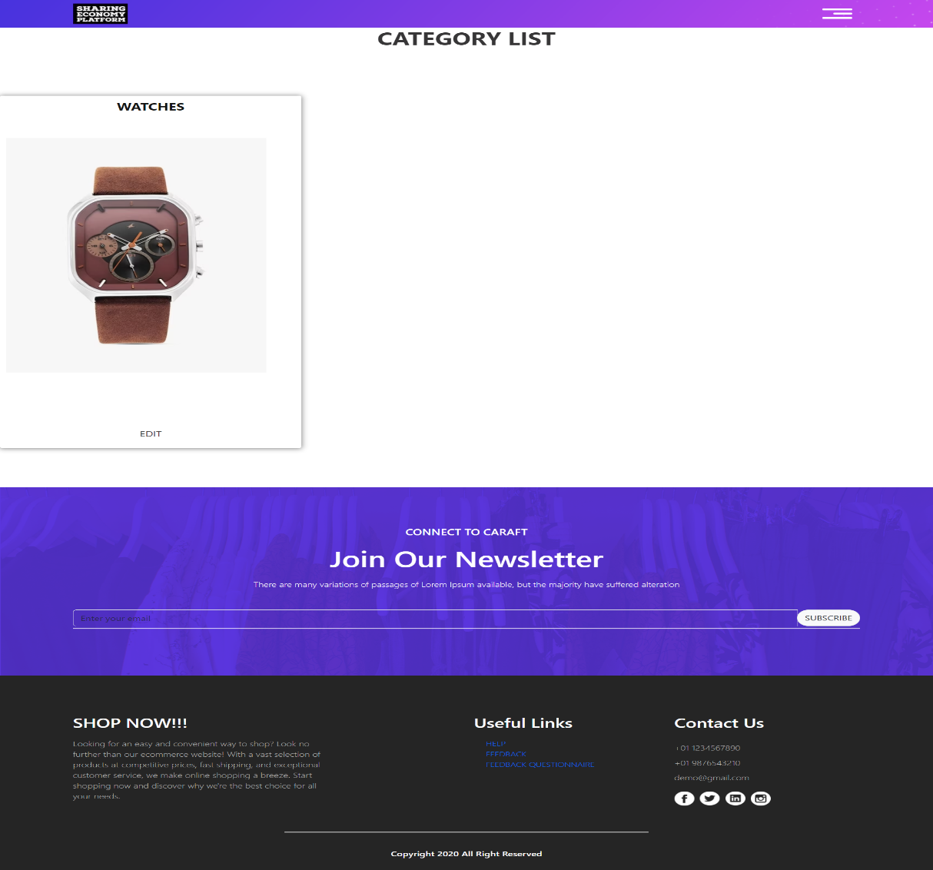**PRODUCT CATEGORY LIST**

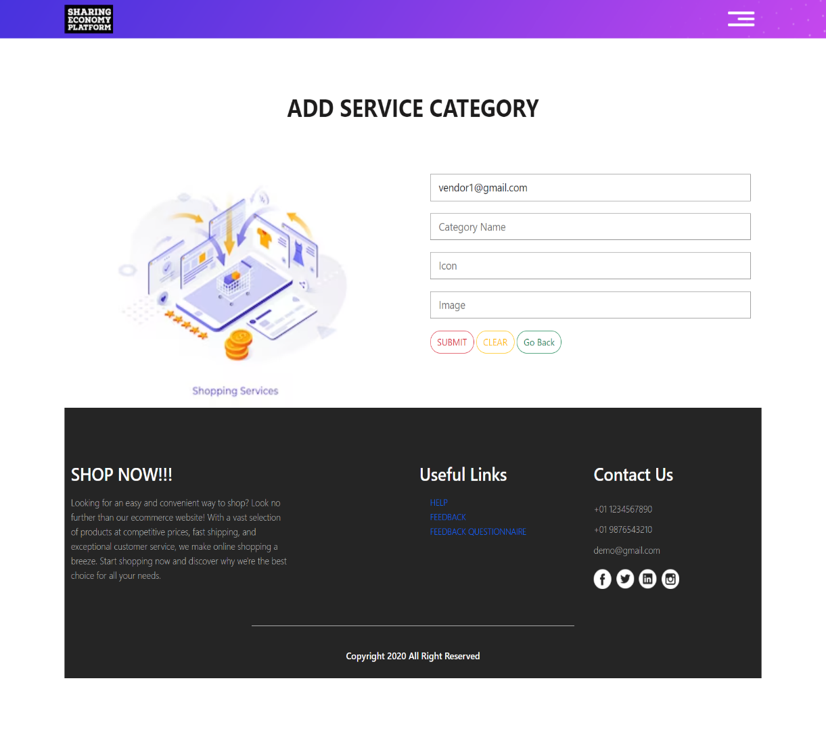**ADD SERVICE CATEGORY**

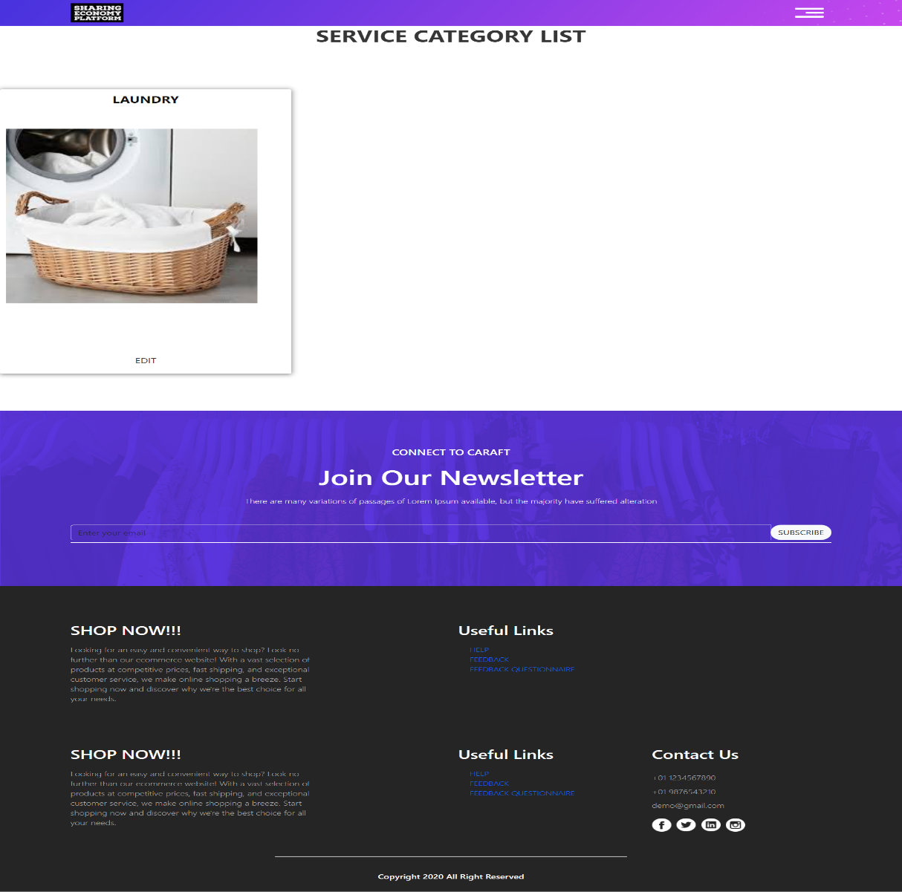**SERVICE CATEGORY LIST**

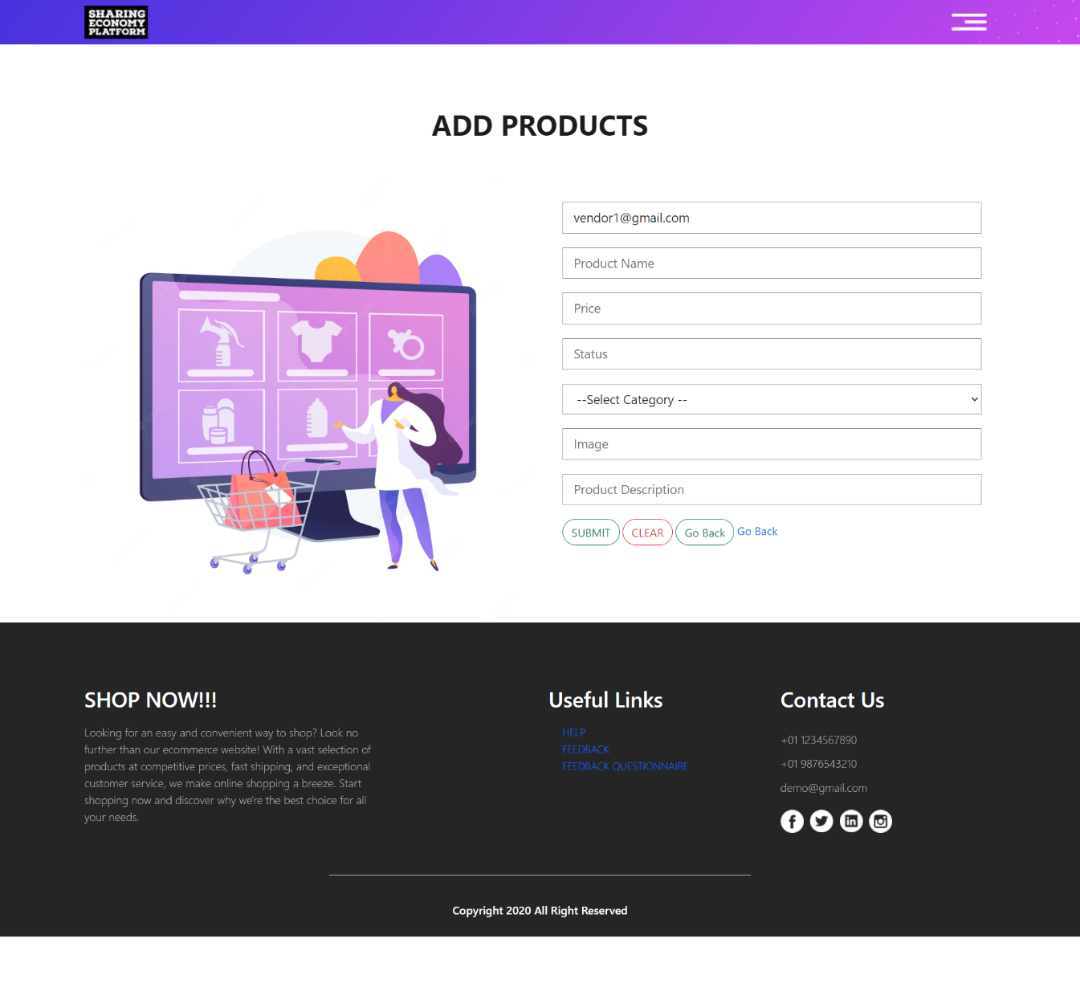**ADD PRODUCT**

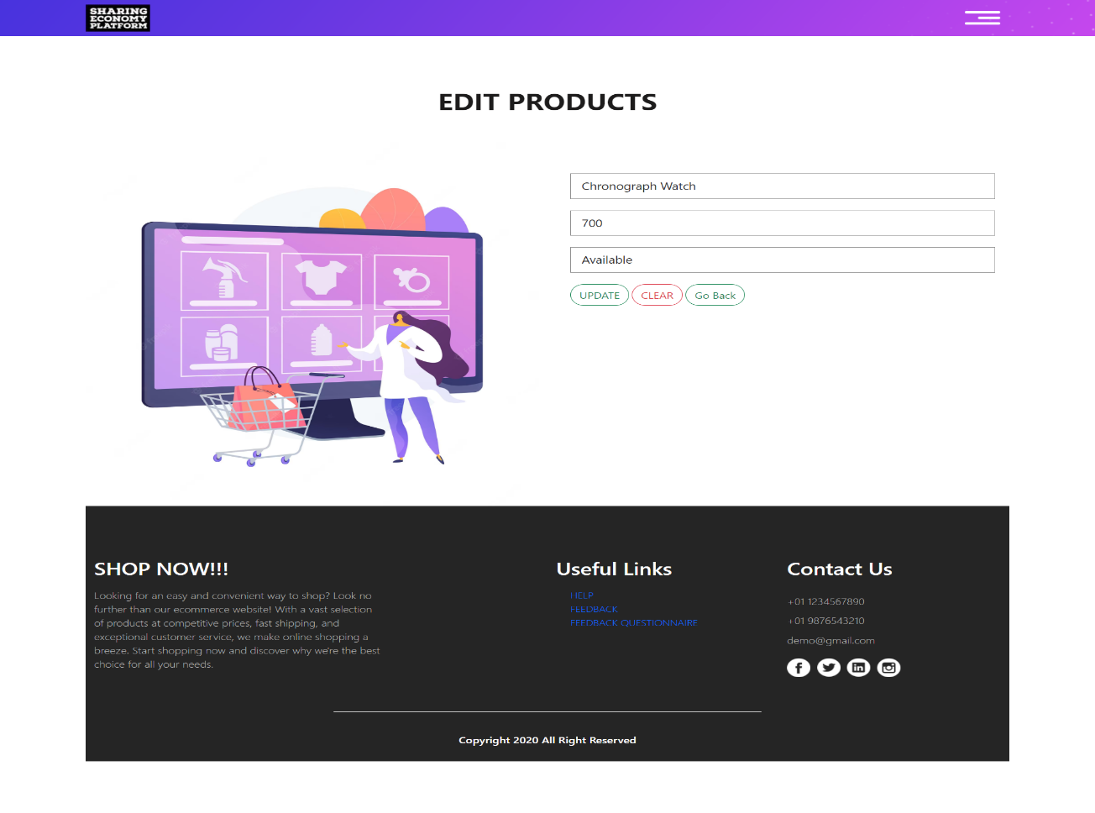**EDIT PRODUCTS**

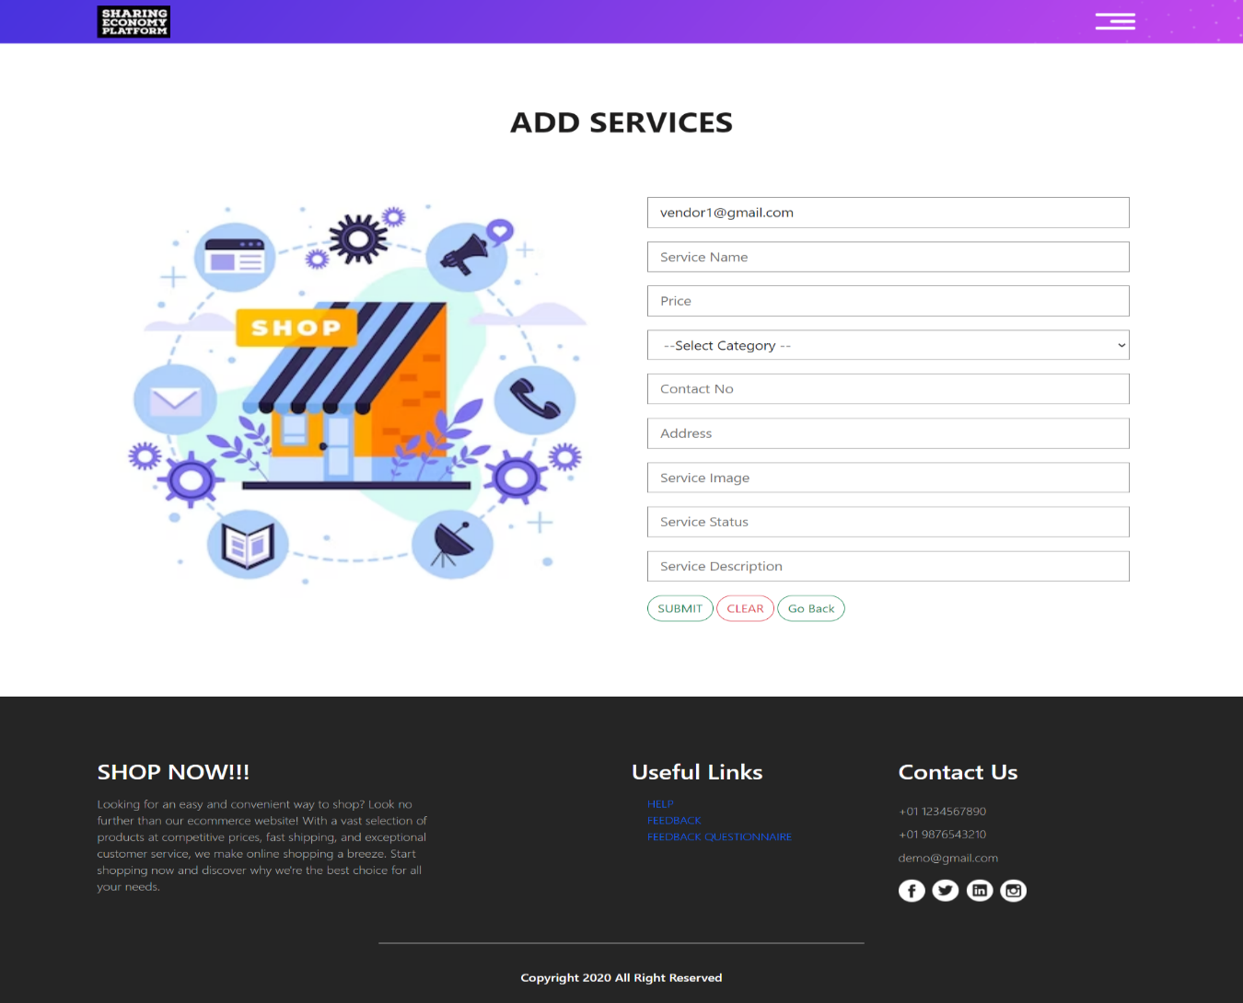**ADD SERVICE**

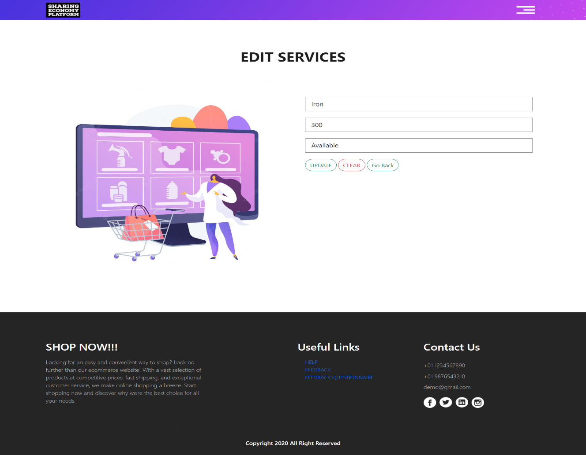**EDIT SERVICE**

**CUSTOMER HOME**

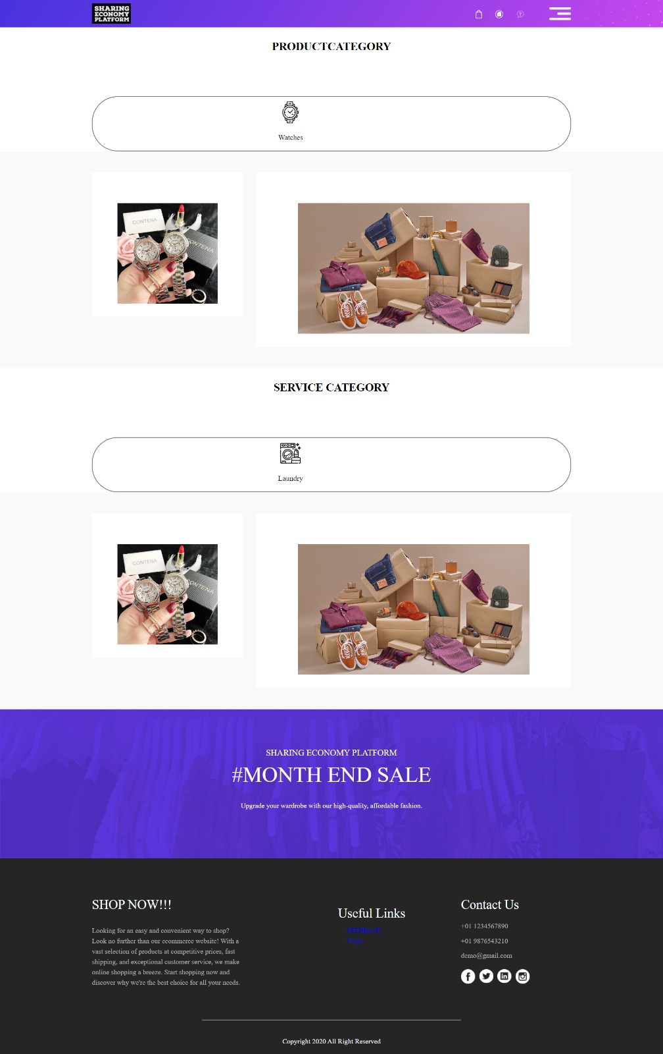

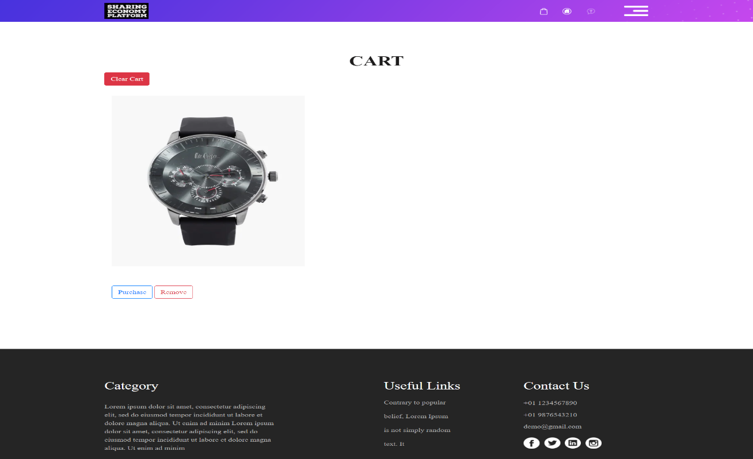**PRODUCT CART**

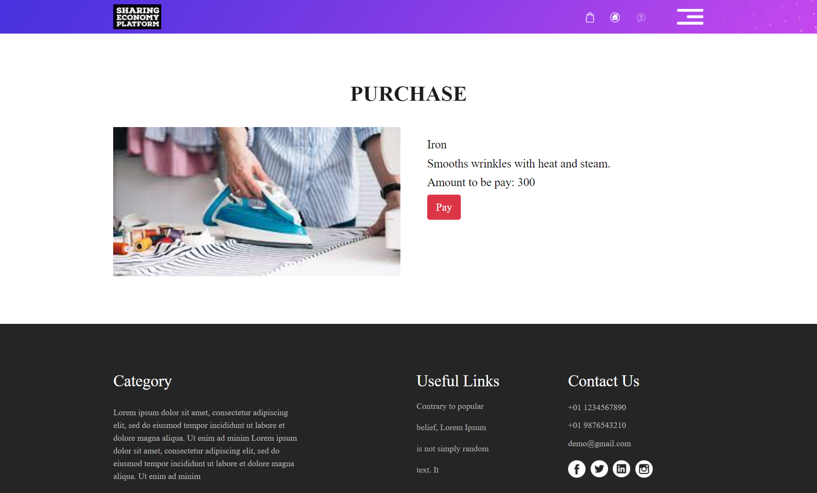 **BOOK SERVICE**

**BILL GENERATION PAGE**

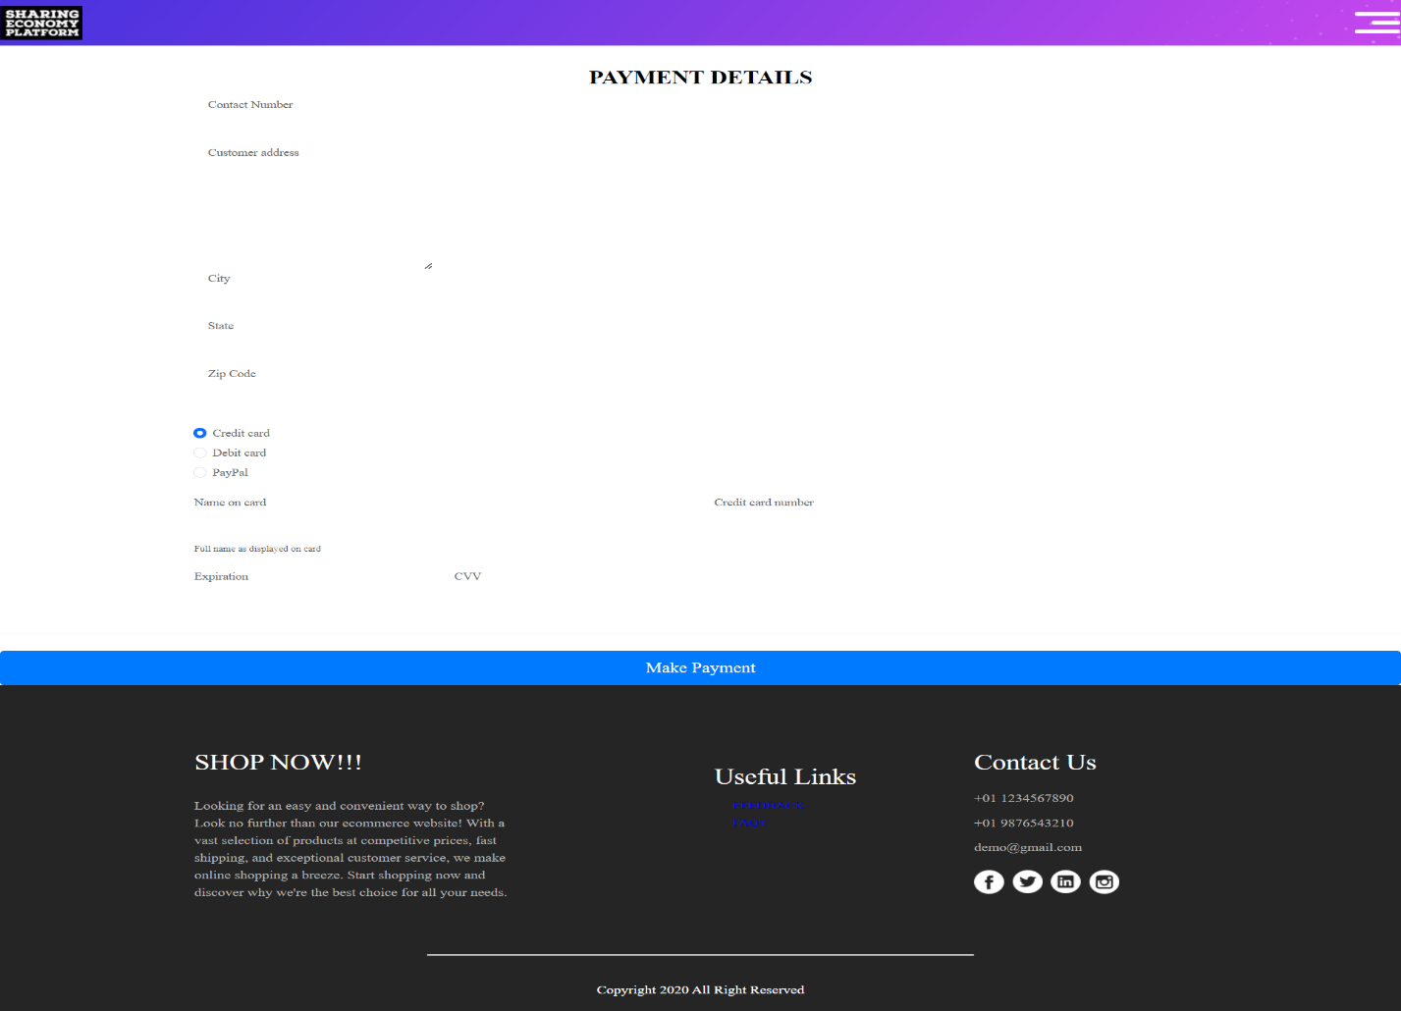

**ADMIN HOME**

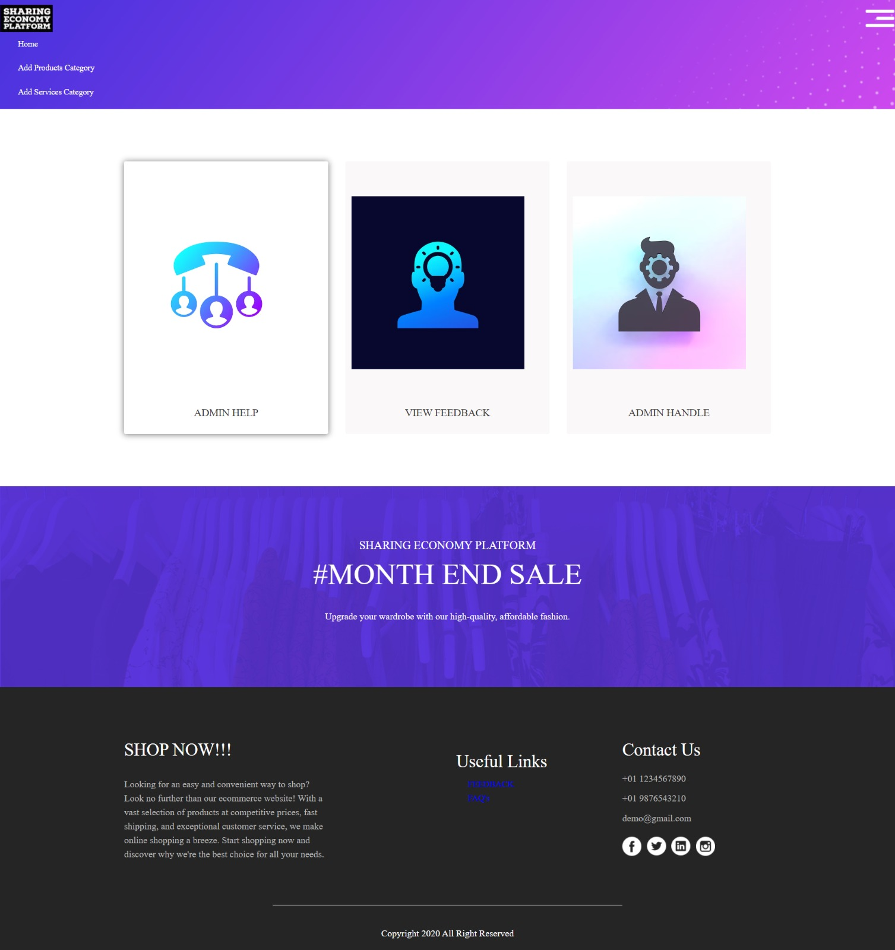

# 5.0 Database Design

## 5.1 Data Model

|  |  |
| --- | --- |
| **Column Name** | **Datatype** |
| userid | varchar(255) PK |
| Admin name | varchar(20) |
| Admin password | varchar(64) |

**1. Admin**

**2. Customer**

|  |  |
| --- | --- |
| Column Name | Datatype |
| Customer email | varchar(255) PK |
| caddress | varchar(255) |
| ccontact | bigint |
| cdob | varchar(255) |
| cfirstname | varchar(255) |
| cgender | varchar(255) |
| city | varchar(255) |
| clastname | varchar(255) |
| cpassword | varchar(255) |
| cstate | varchar(255) |
| czipcode | varchar(255) |

**3. Vendor**

|  |  |
| --- | --- |
| Column Name | Datatype |
| Vendor email | varchar(255) PK |
| vcity | varchar(255) |
| vpassword | varchar(255) |
| vstate | varchar(255) |
| vaddress | varchar(255) |
| vcontact | bigint |
| vdob | varchar(255) |
| vfirstname | varchar(255) |
| vgender | varchar(255) |
| vlastname | varchar(255) |
| vzipcode | varchar(255) |

**4. Cart**

|  |  |
| --- | --- |
| Column Name | Datatype |
| cart_id | bigint PK |
| customer_id | varchar(255) |
| product_id | bigint |
| product_image | varchar(255) |
| product_name | varchar(255) |
| product_price | varchar(255) |
| product_status | varchar(255) |

**5. Feedback**

|  |  |
| --- | --- |
| Column Name | Datatype |
| feedback_id | bigint PK |
| customer_feedback | varchar(255) |
| customer_id | varchar(255) |
| customer_name | varchar(255) |

**6. Help**

|  |  |
| --- | --- |
| Column Name | Datatype |
| help_id | bigint PK |
| customer_id | varchar(255) |
| customer_name | varchar(255) |
| query | varchar(255) |
| solution | varchar(255) |

**7. Product**

|  |  |
| --- | --- |
| Column Name | Datatype |
| product_id | bigint PK |
| product_category | varchar(255) |
| product_image | varchar(255) |
| product_name | varchar(255) |
| product_price | varchar(255) |
| product_status | varchar(255) |
| vendor_id | varchar(255) |
| product_description | varchar(255) |

**8. Product Category**

|  |  |
| --- | --- |
| **Column Name** | **Datatype** |
| product_category_id | bigint PK |
| product_category_icon | varchar(1024) |
| product_category_image | varchar(1024) |
| product_category_name | varchar(255) |

**9. Service Category**

|  |  |
| --- | --- |
| **Column Name** | **Datatype** |
| service_category_id | bigint PK |
| service_category_icon | varchar(1024) |
| service_category_image | varchar(1024) |
| service_category_name | varchar(255) |

**10. Vendor Service Provided**

|  |  |
| --- | --- |
| Column Name | Datatype |
| service_id | bigint PK |
| service_address | varchar(255) |
| service_category | varchar(255) |
| service_contact_no | varchar(255) |
| service_image | varchar(255) |
| service_name | varchar(255) |
| service_price | varchar(255) |
| service_description | varchar(255) |
| service_status | varchar(255) |
| vendor_id | varchar(255) |

## 5.2 Tables Structure

Customer Details:

|  |  |  |  |
| --- | --- | --- | --- |
| **Column Name** | **Data Type** | **Length** | **Mandatory** |
| Customer First Name | Text(12) | Alphabetic | Yes |
| Customer Last Name | Text(12) | Alphabetic | Yes |
| Customer Date of Birth | Date | NA | Yes |
| Customer Gender | Radio Button | NA | Yes |
| Customer Contact Number | Text(10) | Numeric | Yes |
| Customer Address | Text Box | Alphanumeric | Yes |
| Customer City | Text | Alphabetic | Yes |
| Customer State | Text | Alphabetic | Yes |
| Customer Zip Code | Text(6) | Numeric | Yes |
| Customer E Mail | Email | Alphanumeric | Yes |
| Customer Password | Password | NA | Yes |

Vendor Details:

|  |  |  |  |
| --- | --- | --- | --- |
| **Column Name** | **Data Type** | **Length** | **Mandatory** |
| Vendor First Name | Text(12) | Alphabetic | Yes |
| Vendor Last Name | Text(12) | Alphabetic | Yes |
| Vendor Date of Birth | Date | NA | Yes |
| Vendor Gender | Radio Button | NA | Yes |
| Vendor Contact Number | Text(10) | Numeric | Yes |
| Vendor Address | Text Box | Alphanumeric | Yes |
| Vendor City | Text | Alphabetic | Yes |
| Vendor State | Text | Alphabetic | Yes |
| Vendor Zip Code | Text(6) | Numeric | Yes |
| Vendor E Mail | Email | Alphanumeric | Yes |
| Vendor Password | Password | NA | Yes |

# 6.0 Appendices

## 6.1 Glossary

|  |  |
| --- | --- |
| **Acronyms** | **Definitions** |
| SEP  BRD  HLD | Sharing Economy Platform  Business Requirement Document  High Level Design Document |

# 

# 7.0 Terms & Conditions

***Disclaimer: Please do not circulate or distribute this document outside of Cognizant Network, We have a Zero Tolerance Policy. Kindly adhere to 100% Compliance at all times.***

# 8.0 Change Log

*Please note that this table needs to be maintained even if a Configuration Management tool is used.*

|  |  |  |  |  |
| --- | --- | --- | --- | --- |
| **Version Number** | **Changes made** | | | |
| V<n.n> | *<If the change details are not explicitly documented in the table below, reference should be provided here>* | | | |
| Page no | Changed by | Effective date | Changes effected |
|  |  |  |  |
|  |  |  |  |
|  |  |  |  |
|  |  |  |  |